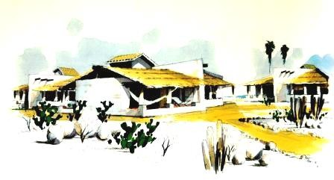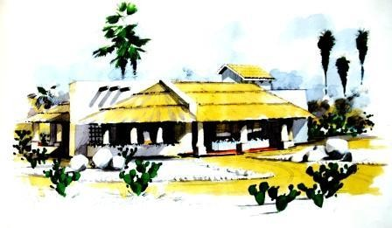
Letters 117
Puerto Escondido Ashram on the move! 350
meters of beach, cabins. Multipurpose Room, Dining Room, Bedrooms and... Chamber.

On the evening preceding Christmas Day, December 24, I met with the Getuls in their Cuautla Chamber and told them that their attitude of not giving opinions on matters pertaining to the High Hierarchy was correct. Of some fifteen hundred Getuls in the world of the RedGFU, only about two hundred responded to the survey given to them and of the two hundred, only about one hundred gave an opinion in favor or against. This reaffirmed that initiatory consciousness is not political. We are doing well.

I met with the Gag Pa's on January 18 in their Coatepec Chamber. We talked about the characteristics of their Grade. I recommended them to support the Getuls and to observe the Gelong. In the Line of Sacred and Royal Initiation you receive a degree when you already have it and you have to start working on the next one, in your case the Gelong, and support yourself in the degree already passed, the Getuls. Thus the Order is maintained in order.

I meet regularly with the Gelongs. I participate in their Permanent Electronic Session via the Internet, which I recommend that they maintain in each of the Degrees, without meddling in matters of Higher Order. The Gelong are fulfilling well their role as Guardians of the Path that Leads to the Holy Land, which, in the Piscean Age, led to a Sacred Sepulcher, now leads to the conscious- ness of the Total Self.

The Honorable Guru Don Gustavo Toro recently officially inaugurated the Buenos Aires Ashram and is now traveling through Cordoba, Argentina, guiding the work of the Piedras del Sol Ashram, after having stimulated the Ashrams of Paraiso and Tena in Colombia. The Honorable Guru Don Carlos Michán informed me that he would be in San José, California, and from there he would go to Venezuela. I entrusted him with a project of strategy to expand the Initiatic consciousness in North America. I do not know anything about Don José Michán. In general, the RedGFU is advancing at a good pace as a Fraternity and as an Order in all the Continent and in Europe.

As a counterpart to the case of New York, the project of construction of the facilities for the Inter- national Ashram of Puerto Escondido in Oaxaca is advancing, with the strong support of the Gap Pa Lucia Cordero, the Getuls Oliva Marroquin and the Gegnian Don Angel Armenta. In order not to be left out of this magnificent work, I have offered an Update Course and Practical Application of the Wisdom Traditions during one week, for March or April of this year, if it fits within the general project. Puerto Escondido is a small city, but it has an International Airport and direct Charter Trips from Europe and USA, as well as connections with Oaxaca City and Mexico City by land and air.

This Ashram will represent the synthesis of the experiences of the best we have achieved for human development, environmental education and transcendental experiences. In addition, it will be an international center for family recreation with excellent climate, vitality and synthesis teachings. The project contemplates the construction of time-sharing bungalow and normal Ashram practices, with Gymnastics, Martial Arts, Cosmic Ceremonial, field work, Yoga, Studies and Meditation, open to the World Brotherhood and their families.

The Initiatic panorama is clear for this new year. Communications are slowly improving within the two lanes of Reality that the thought of the MSMA and the Line of the MVHM, the one of contraction and the one of expansion, with its secondary channels in both currents, which leaves the Central Way, the Way of Being, better and better defined in all the planes synthesized in a Fifth Plane, Essence or Sun.

The Sacred and Real Initiation, by definition, is inclusive and not exclusive, as is sometimes thought when one insists on emphasizing only one of its currents. The problem of Consciousness is to understand this process without existential fears. Initiation is Life and Life includes the two po- les, that of contraction and that of expansion, which manifest in Material Reality as Space and Time and as life and death. In Psychic Reality as a wide range of values encompassed within the concepts of Good and Evil. In Mental Reality as possibilities of involution and evolution acting through constants which are the Universal Laws. Spiritual Reality, generally known as mysticism, generates the ritual of life and death, of all complementary opposites, through Love and Freedom.

The sense that is common to this whole process of Reality is the circulation, curved and continuous, of unity towards diversity and of diversity towards unity, that is, the universal sense, sometimes suggested as Circulation of Light.

We Human Beings are totally involved in this process in all aspects of our essential and spatiotemporal nature. That is why the essential, the Self, remains and the Human changes. Our behavior is the result of this process and gives us a slight margin of choice that gradually increases due to the set of experiences that we accumulate in the Soul and that manifest themselves as Consciousness, as the capacity to do or not to do, or to do otherwise what it is for us to do. This gives rise to the struggle for survival that evolves from the instinctive to the valuative, to the rational, to the universal and to the transcendental.

For Human Consciousness this universal process of life is like the climbing of a great mountain that begins by revealing our relationships with the immediate in the form of need. Higher up the vision widens and gives opportunity to choose what responds to the need in a wider and more selective time frame. And so on, successively, with greater space and time, as the landscape widens from higher levels. Finally, from the top of the mountain the panorama includes the sets and associated sets of sets such as forests, rivers, meadows, crops, villages and so on. But also, from the summit another mountain, higher, stands out against the curved horizon that reaches our gaze.

In practice, everything seems to be reduced to a simple struggle for power to prevail over the forms of life and the individuals who participate in this marvelous process of self-awareness. However, the Common Sense that is generated in it, already has the presentiment of something Superior for our condition and awakens our Faith, outlining possibilities of finding a Way, a Path, a course to- wards the best of ourselves that is complemented with the experiences of the consciousness of the soul and gives us Wisdom to live. This is what we call Real Initiation.

The prototypes of this Wisdom are the teaching of the MSMA and the life of the MVHM.
Sat Arhat José Marcelli
January 26, 2007
www.redgfu.net/jmn

Original text in Spanish:
www.josemarcellinoli.com/2007/pdf/2007_cartas_117.pdf
Translation by: Marcos Paulo González Otero
email: gmarcosp@gmail.com
www.otero.pw
WhatsApp/Telegram: +52 686 119 4097
Version: 30082022-01
Please feel free to forward opinions and corrections.

