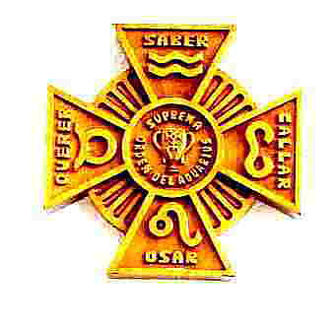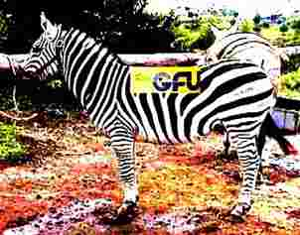
Letters 120 (Excerpt from the book Aum Tat Sat, in preparation) The starting point is the Universe. The Universe is one and it is diverse. It is a paradox where words begin to lose their meaning. The same happens with the Human Being. As Being is one, as human
is a set of sets of particles associated with a common purpose that give each individual a particular, individual consciousness, different from that of any other individual. Being is Truth, Human is Reality, relativity, change. The Sacred and Real Initiation aims to create a bridge of consciousness between Being as Truth and Human as Reality. The experience of total Human Being, where the Truth of Being is reflected in the Space-Time of Human Reality, and both are identified in the Total Human Being with an experience of unity that the Initiates call Enlightenment.

Truth remains, Reality changes. Truth is Pure Potential, Reality is form and existence energized by polarity. Because of this, Truth, as Pure Potential, remains and changes as Reality. Perhaps this is why the mystics think that Truth, God, the Cause of all Causes is Triune. That is, Truth and Reality are consubstantial and cannot exist one without the other in the consciousness of the Human Being. Truth is one and Reality is dual, total three, just as Human Beings, one as Being and two as Man and Woman. The Self, without the human lacks Reality; the Human without the Self is an illusion. However, the Human Being is Truth and is Reality, simultaneously. That is why it changes as human and remains as Being. This is a simple example. There is no need to resort to imagination or Faith to make sense of it. Faith is the corollary of Consciousness. That is, the presentiment of something superior to the Human Being. This presentiment is what stimulates the Consciousness to nourish itself with experiences, and the experiences accumulate seeking its return to the original Unity and constitute the Individual Soul that serves the Being as a mediator in the arduous task of maintaining individual unity within the immeasurable possibilities of Reality. For their part, the individual souls, as a whole, continue to seek unity and constitute themselves into the Universal Soul. The All is and is in all. It stands as unity in diversity, as Macro and Micro Cosmic Universe.

In this order of ideas, Maître de la Ferriere proposes the use of thesis and antithesis to arrive at a synthesis that can be converted into matesis, into experience.

Also, the Master himself warns his Disciples against generalizations, which may be valid at a certain moment of the general process, but when repeated excessively can lead to the formation of prejudices of creeds, races, sexes or social classes entering the Initiation and prevent him from acquiring new experiences and experiences to enrich the soul and conscience. It is at this point in the process that the Work of the Initiates can stagnate and create dogmas that occasionally produce ruptures, exclusions, heresies and elements of conflict that provoke holy wars and witch burnings, at least symbolically, as often happens with dogmatic religions. The ideas of the Master de la Ferriere are socially embodied in a Great Universal Fraternity for human development and in an

Order of Initiates to seek the harmonious solution of Reality as a basis for experiencing the transcendental essence of Truth. Naturally, the difficulties of this project are sometimes unexpected and even contradictory as has been seen in practice by observing the attitudes of the Disciples of the Grand Master. This has to be so because each Human Being is an original, unrepeatable project and each one has a particular concept of Reality and of the changing circumstances that this reality presents him, according to the time, the geography and the idiosyncrasy of the society in which he lives. It is not surprising that in the name of the Grand Master there are the most dissimilar proposals, declarations and acts of pressure trying to implant an exclusive way of thinking, interpreted by very different consciences. Such is the case of his great disciples who could never reach an agreement, even though they tried alliances and staggered participations that turned into declared or surreptitious aggressions that were reflected in the attitudes of his own disciples and are still reflected in the disciples of his disciples.

This does not mean that the Grand Master's project is doomed to failure, but that it will gradually be understood as the historical and cosmic process of humanity advances within the New Era that he advocated, as is beginning to be seen today from very diverse social angles that seem alien to his thought, but that are occurring according to the historical and cosmic process of the New Era that involves all Human Beings. Within this process, the advance of communications plays an important role, for better or for worse. The fact that their ideas are openly discussed before an audience, which can become worldwide, implies risks that are healthy for those who discuss them, because by the same magnitude of the diffusion they are exposed to be refuted or reaffirmed from many angles that are unpredictable. Thus, at the end of the day, the openness of communications is a guarantee factor against half-truths and dogmas. The Work of the Grand Master de la Ferriere has much to gain and nothing to lose because all his thought is projected towards Being and not only towards Power or Having.

The noble figure of a quadruped with many lines, a Zebra, humorously represents the present Great Universal Fraternity, where there is room for all, from the humblest strata of shamanism to the most sophisticated structures of spirituality, without prejudices of creeds, races, sexes or classes. As for the mechanisms to maintain an orderly development, the Grand Master's Pectoral Cross points out the convergence of the four human aspects in the Fifth possibility, in the Being, as a meeting point, of materialism, art, science and religion exemplified by the life of the Initiates of the Age of Aquarius. The famous Power X of the Master, which is the synthesis of all that is human centered by the Self.

The fact that the Disciples of the Master have not been able to agree on the best way to put his project into practice underlines the need to accept the pluralism of human consciences without centralist hegemonies or messianic promises or punishments, but in impersonal efforts united by mutual respect and trust in human unity around the Self as a common denominator. The new Disciples will have to show with well done deeds the dignity of their hierarchy without resorting to esoteric scales or seniority rights.
Sat Arhat José Marcelli
March 02, 2007
www.redgfu.net/jmn

Original text in Spanish:
www.josemarcellinoli.com/2007/pdf/2007_cartas_120.pdf
Translation by: Marcos Paulo González Otero
email: gmarcosp@gmail.com
www.otero.pw
WhatsApp/Telegram: +52 686 119 4097
Version: 30082022-01
Please feel free to forward opinions and corrections.

