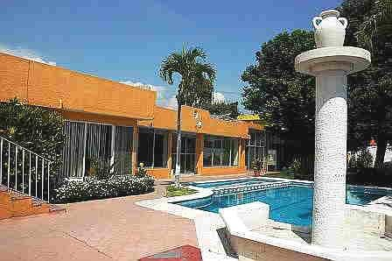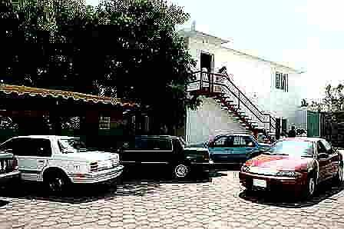

Letters 121

Last weekend I was in the Ashram in Cuautla, Morelos, Mexico, watching people having fun and working within the Line that the MVHM pointed out to us. It seemed very common, but it was something different. Most noticeable were the children playing at their leisure in the meadows or splashing in the stream that crosses the Ashram. Then there were the adults sitting very formally on the lawn participating in a course and those practicing Yoga in the Dome. Inside the Multipurpose Room the Honorable Permanent Board of Directors was in session, quietly... on the outside. Inside the Chamber was a group of Getuls trying to build bridges between the Human and the Sacred while Don Rodolfo, the Elder, was overseeing that all was well. Doña Marta, the Mother, was tasting the stews in the kitchen and Don Raul, the Landscape Architect, was watching over the trees and meadows. Nothing exceptional, apparently, but very significant for the MSMA's Human Reeducation project.

At noon on Sunday we went to the city of Cuernavaca, in the company of Rosita, the Gag Pas Jaime Bobadilla, Alicia Bobadilla and Elsa Aguirre to supervise the work being done in the Headquarters of the RedGFU and to make a speech to the Brothers. I already knew what it was about, but I was pleasantly surprised by the commitment and generosity that everyone put into it. I had suggested that they set up a room for the visits of the SOA Masters and I found an independent apartment, on two floors, with a meeting room on the first floor, living room, bathroom, office and bedroom upstairs. In addition, I could appreciate the care they take to keep their Headquarters active, clean and beautiful, which means giving Yoga, Martial Arts, Meditation and swimming classes all day long, and holding cultural events with music and vegetarian banquets whenever possible, attended by Brothers who work in an impersonal way, without payment or preeminence...

On the way back to the World Headquarters in Mexico City, memories buzzed like bees between my heart and my head.

- Maestro - the then Getuls Elsa Aguirre told me - I want to do something for the GFU of Cuernavaca, where do I start?
- The first thing we need is to get a house of our own. I know that costs a lot of money and we have nothing. But if we encourage the Brothers the work will keep them united and active. Let's start by looking for a piece of land or a house in a suitable place for our activities.

A few days passed and Doña Elsa called me to tell me:
- Master, I visited some friends and they are selling us a large piece of land at a low price, would you like to see it?

A large plot of land at a low price in Cuernavaca - I kept thinking - either Doña Elsa is a magician or someone is joking. But I went to see it. Yes; there it was, solitary, independent, with ten thousand square meters, paved roadway, all urban services and ... a forty-five degree slope towards a ravine with no horizontal planes - beautiful! for whoever could invest a good amount of millions of pesos in making a staggered construction, with terraces, viewpoints and even swimming pools.

- Buy it - I said - the price is very good.
- The brothers don't like it - commented Doña Elsa. They say that it is good for mountaineering, but that it would be dangerous to practice Yoga there.
- I advise you to buy it.
A few days later Doña Elsa spoke to me again:
- We already bought it by raising money with loans, what do we do now?
- Advertise it as a prime location for a resort or residential complex.

After some time I asked what had happened.
- Nothing, Maestro, nobody wants to buy it. The only thing that a construction company offered us was a trade of the land for a neglected house with two thousand five hundred square meters in a flat place between two streets.
- Accept the barter.
The rest was work, a lot of work. Now it is one of the best houses in the RedGFU, with swimming pool, gardens, Yoga and conference rooms, premises for Schools and administration; commercial premises, summer dining room, own paved parking lot and the apartment for Teachers that I went to inaugurate without having spilled a drop of sweat.

Naturally, everything was due to the High Magic of the selfless work of many people. People of great human quality passed through there. I do not mention them because I may commit the injustice of forgetting some of them (And here among us, I no longer remember the names of all of them, although I see their smiling faces in my heart). What I can assure you is that the MSMA and the MVHM will not forget their True Names.

Spring is peeking through the window of the office where I work, and also, the questions are spring- like after the daily Cosmic Ceremony:
- Master, if Truth is Unity and Reality is Diversity, the Universe, why do I need to search for Truth and find it in Reality?
- So as not to repeat the History of Humanity that says: "They were born, they ate, they grew, they reproduced and died without ever knowing why or for what purpose".

Sat Arhat José Marcelli
March 12, 2007
www.redgfu.net/jmn

Original text in Spanish:
www.josemarcellinoli.com/2007/pdf/2007_cartas_121.pdf
Translation by: Marcos Paulo González Otero
email: gmarcosp@gmail.com
www.otero.pw
WhatsApp/Telegram: +52 686 119 4097
Version: 30082022-01
Please feel free to forward opinions and corrections.

