Letters
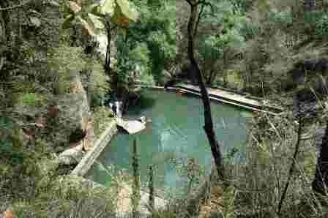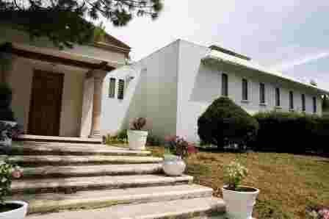
122

Spring began with a whirlwind trip to the World Inner Ashram for the Gelong Day meeting. Attendance was minimal and the results were optimal, not because of the shortage but because of the commitment of those who managed to attend. The Governmental Authorities decided to change the holiday - I guess to protect the Pre-Columbian Monuments from the massive visits of cosmic energy seekers - Then followed the visit to the Umécuaro Ashram for a Zone Meeting with Aquarians from Michoacán, San Luis Potosí, Querétaro and Guanajuato.

The first technical stop was in Morelia, at the Getuls Doña Leonor Vegetarian Restaurant: Fruit salad with a circular slice of papaya and a watermelon cola leonina, juicy and fresh. Purépecha bean soup with corn tortilla and traditional secret condiments, hummmmm! Nopalitos tacos with mushrooms and molcajete sauce, requetehummmmm! Plum dessert with sweet potato and lime water. The mole and other spicy delights remained hidden from me but were noticeable in the color changes of the surrounding faces full of satisfaction in brick red versions and hot flashes of ecstasy.

We found in the rooms of the Ashram the traditional fruit bowl filled with the best products of the fruit trees of Michoacán and the welcome sign of Elder Don Ambrosio and Mother Doña Esther, Thank you! And to work with Meditation, inside the big tent set up on the basketball court. At the end silence and deep identity, Being.

- Master, what are mantras for?
- It is difficult to explain in words. I will resort to a parable: In an orchestra there are musicians with very different instruments. The conductor indicates the key in which the piece is to be played so that all the musicians can tune their instruments and orchestrate with different sounds. This is the Mantram. The one who directs the Meditation indicates the tone in which the different phases of the Meditation with the Mantras are performed, so that all meditate in harmony, without renouncing their own characteristics, and the Meditation acquires unity within the diversity of the meditators.
- Do the sounds of the mantras have any meaning?
- Yes they do, but it cannot be said with simple words either, because mantras serve as bridges between Reality and Truth, between the Human and the Self. However, poetically their meanings can be suggested, according to the sensibility of each one. For example, the AUM means unity in diversity. The first A represents me, the U what unites me to everything and the whole is the M. And so on, like this. AUM MNI PADME HUM can be suggested as: I reverence the Light of the Self that shines in the Lotus of my heart, etcetera.

At five o'clock in the morning Harmonization in the Great Chamber, in the open air, with light classical music under the starlight. Fresh forest-scented air and troops of pine trees in the position of firm! Then Whu Shu: I salute my Brothers, TAI, the Supreme, in Yin and Yang version! Three different TAI and only one True TAI. Strength with softness! Twists, forwards, backwards, left, right, center. All coordinated with the breathing rhythm. Pause. Deep self-awareness.

- The Staff is the symbol of the path to travel, the Tao, with eight reeds, the Octuple Path, the seven stages or planes of Life and the passage to a higher dimension, all within the stature of the one who seeks the path. It is necessary to find a propitious day for the body and the soul and to enter a bamboo forest to look for a reed with eight reeds that has the measure between the soles of the feet and the crown of the head. Then one must be deeply serene and talk soul to soul with the chosen bamboo to ask permission to use and dignify its reed. in the noble practice of the Tao Te Chia, the Path of the Virtue of the Righteous Middle.

Once the consent of the Bamboo has been obtained, it must be cut and placed lying on a meadow or platform where it can receive the sun for eight days. Then it must be stripped of its branches and a fine perforation must be made at the base of each of its canes. Then it must be passed through the fire of a fire lit especially for the act, as many times as necessary to remove the moisture and make its fibers more flexible. It is important to do this flaming with softness and rotating the cane so that it does not burn in some parts. In addition, each time it is made to pass through the fire, the whole cane should be cleaned with a piece of thick cloth or burlap to maintain its natural shine.

- Let's continue! Feet parallel and slightly apart, knees flexed and the weight of the body loaded on the pelvis. The Staff is taken between the thumbs and index fingers of each hand to keep the soft- ness with strength and the Hara active between the kidneys and lower abdomen. However the self- awareness should be kept at the level of the heart.

At seven o'clock in the morning, Cosmic Ceremonial, after a water bath at room temperature. The Master salutes, wishes health, raising the four fingers of the right hand which represent the body, the force, the intelligent order and the unity of Life, keeping the thumb folded on the palm as a symbol of the occult and Sacred: PAX...! Then he kneels and joins the thumb and index finger and points to the union of the Demiurge and the Theurgist at the level of the heart, in masculine and feminine, and asks the Father, as Supreme Being, in his own Human Being, to do his will. Then he opens his arms and pronounces AUM TAT SAT! which means I am Thyself, and begins to officia- te the Ceremonial with a prayer: O Maker Hear me...!

In the morning maintenance work for the Ashram; at noon Yoga, in the afternoon study with open dialogue between the Master and the Disciples. In the evening Meditation for the Universal Frater- nity and Chamber for members of the Order...

A day at the Ashram.
Sat Arhat José Marcelli
March 25, 2007
www.redgfu.net/jmn

Original text in Spanish:
www.josemarcellinoli.com/2007/pdf/2007_cartas_122.pdf
Translation by: Marcos Paulo González Otero
email: gmarcosp@gmail.com
www.otero.pw
WhatsApp/Telegram: +52 686 119 4097
Version: 30082022-01
Please feel free to forward opinions and corrections.

