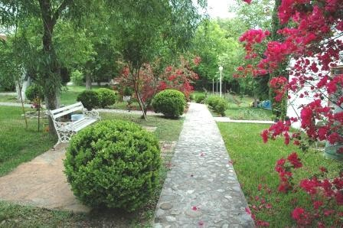
Letters 124
RedGFU Ashram, in Raíces, N. L., Mexico.

- Passengers to Monterrey can board their flight.
- Excuse me, here is your money. We made a mistake in charging you extra. The company apologizes.
- Good; tell the company that I accept their apology and that I now know they are a company that can be trusted, especially when it comes to getting off the ground a little. We can all make mistakes and if we admit it, it's OK. I remembered NY.

Once in flight I started to read the news in a newspaper. The main cartoon compared Mr. Bush's figure with the photograph of the Korean student armed with two pistols who killed 32 classmates in the USA, and added that we must be alert with Mexico because it is dangerous. In his column, Mr. Catón said that he preferred the naivety of the one who bought the Eiffel Tower to the cunning of the one who sold it to him. Again, subversive ideas came to my mind and I remembered the initiatory degrees to be awarded in May.

Before landing I had a bird's eye view of the land of the Regios with its large industrial complexes lined up on green areas. At the airport were Don Enrique and Doña Marina, the Elder and the Mot- her of the Raíces Ashram; Don Alejandro and Doña Teresa, Ex of the same Ashram, and Doña Evelyn, all smiling and firm, trustworthy people. At the Ashram, Anabel and Lupita were waiting, with new curtains for the Masters' room and Don Timoteo, the gardener, who keeps impeccable some five hectares of gardens, all by himself, and from time to time lends a hand to go shopping or fix something out of order. There is no doubt that the Regios are stingy. In other places, with more generosity, we need five or six gardeners to do the same job. And the same in everything else. The funny thing is that the ones around here are cheerful and don't complain.
No way, we have to work. Open dialogue with the Master. To open the dialogue I tell them that a Sacred Book says that "All that was continues to be and all that will be already is, but the rain falls

attending to the invocations of the thirsty gardens." In other words, I am not going to make speeches to them and we will talk about what they need to know and not what I like to hear myself say.
2
- Maestro, what do you think about the decriminalization of abortion in Mexico?

Inside I wonder if I will look like a priest or a politician.

- I must confess that I have no direct experience in this matter. I believe this is a women's issue. However, I have lived long enough to realize that abortion cannot be decriminalized. I wish and this issue could be settled with a fine or a few days in jail. It is much more serious. It is a matter of honor, of respect and of defending those who cannot defend themselves.
- Who is the one who cannot defend himself?
- The Being, with a soul that is struggling to enter the human plane. However, the Law of Universal Compensation is on its side and punishes those who open the door to it and, already within this plane, expel it ignominiously. And this Law concerns both men and women. They say here on the ranches that he who kills the cow sins as much as he who grabs its leg.

Silence. We change the subject.

- Whose responsibility is greater, Master, the one who grants an Initiatory Degree or the one who accepts it?
- Let us analyze the matter a little. The InitiaticDegrees are not granted, they are recognized. Nor are they accepted or not accepted. They are held or not. The only one who can recognize a Degree to a Disciple is his Master. All responsibility is the Master's. Then, another question arises, who recognizes the Degree of a Master? His Master, naturally. And so on, successively, when the matter is not more than home or family, but if it is a matter of fulfilling a mission or carrying out a project, the recognition of an Initiatic Degree requires the permission of the Superior of the Order.
- Don't you think it is better, for practical purposes, to have them recognized by majority vote?
- In a first instance it can be done in this way, as a proposal, but not in a definitive way, because without the permission of the Superior the act of recognition ceases to be a Sacred and Real Line of Initiation and becomes a practice of distribution of political power.
- In our case, the Superior of the Order is the Most Honorable Collegiate Body, in which the entire High Hierarchy participates.
- 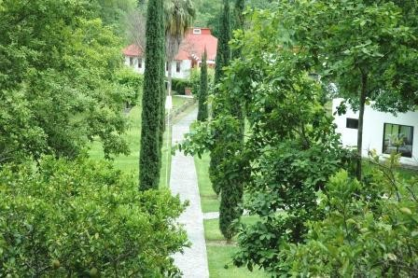The Most Honorable Collegiate Body cannot replace the figure of the Master. The figure of the Master of the Highest Degree recognized by the Master of the Line represents the Superior Master of the Order. In our case there were only two Masters accepted as such by Master Estrada - "To follow Estrada is not to follow a Man, it is to follow a Line..." One of the two recognized Masters decided to form another Line and the other decided to continue the original Line. In any case, the Line will continue with the Master designated by the current Superior. This is a right that has always been recognized from Warlock to Avatar level.

Sat Arhat José Marcelli
April 22, 2007
www.redgfu.net/jmn

Original text in Spanish:
www.josemarcellinoli.com/2007/pdf/2007_cartas_124.pdf
Translation by: Marcos Paulo González Otero
email: gmarcosp@gmail.com
www.otero.pw
WhatsApp/Telegram: +52 686 119 4097
Version: 30082022-01
Please feel free to forward opinions and corrections.

