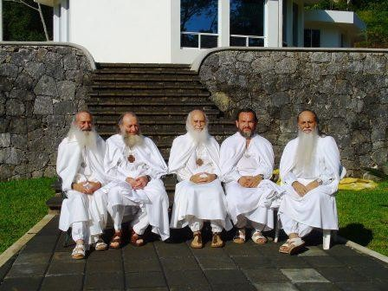

Letters 131

Everything went well, from the beginning. The Martial Artists presented themselves with four hundred elements, mostly young, disciplined, agile, ready to fulfill the three slogans of TAO TE CHIA: Prepare not to fight, to overcome ignorance about themselves and ready to serve life. His presentation at the Veracruz State Theater was approved by acclamation; his work at the World Inner Ashram was exemplary. A greeting from the Great Dragon to the two Guardians of the Crystal Sword, the Gelong Don Ruben Garcia and the Gag Pa Don Ernesto Gonzalez.

At the inauguration of the Ashram in Puerto Escondido, on the coast of Oaxaca, one hundred and twenty-five certificates of attendance to the Initiatic Refresher Course were signed and their families and companions were accommodated in the palapas, tents and in the first time-share bungalow that has already been built. The Oaxacan Brotherhood remained helpful, as always, under the Inspiration of the Gag Pa Doña Lucía Cordero, the Getuls Doña Oliva Marroquín and the Gegnián Don Roberto Estrada, all with the logistical and effective support of the Angel, Don Ángel Armenta. Thank you.

The World Meeting of the Supreme Order of Aquarius exemplified the Great Unknown, the X, the apex of an Obelisk with four slopes and a common center, the Fifth Essence, the Fifth Sun or Fifth Universal Kingdom, the Kingdom of Being without beginning and without end, the Initiation of the Real in the Sacred. His presence in the World Inner Ashram of the RedGFU was a feast dedicated to the encounter of the Total Human Being.

For the third time the World Meeting of Elders, Mothers and Dwellers of Ashrams was held, with the attendance of representatives from twenty-five of the twenty-seven Ashrams that operate in different countries. The exchange of information was excellent, as well as the training courses in

Ecology, Promotion, Administration, Initiatory Protocols and Community Organization. The centerpiece of this meeting was the Gelong Rosita Esquivel serving as International Coordinator of Ashrams.

The highlight of all these Meetings was the Fourteenth Meeting of the Most Honorable Collegiate Body of the RedGFU and its Order of Servers, the Supreme Order of Aquarius, with representatives from the Gag Pa to the Sat Arhat Degree.

The volume of information on the work carried out by the various administrative units and Schools of Initiation in twenty-six countries during the last two years was impressive. The agreements that were derived from that information for the exercise of the following biannual cycle were accurate, attached to the current reality and to the general project of Human Re-education that the MSMA pointed out to us through the MVHM. Among these agreements, the appointment, for the first time, of a Superior of the Order and the exaltation of three new Gurus that will reinforce the high-level hierarchical structure stand out.

As an immediate result of these agreements, the First Secret Chamber of Gelong of the New Age was inaugurated and then consecrated, with all the protocols of the Sacred Tradition, on July 28th, 107th anniversary of the birth of the MVHM. Moreover, a Pact of Honor was made between the High Hierarchy where any irregularity will be sanctioned with withdrawal from the Order.

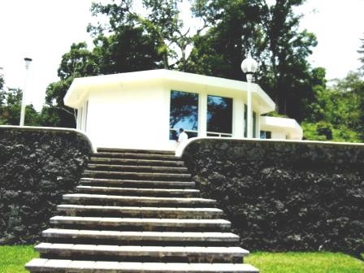

Sat Arhat José Marcelli
July 1, 2007
www.redgfu.net/jmn

Original text in Spanish:
www.josemarcellinoli.com/2007/pdf/2007_cartas_131.pdf
Translation by: Marcos Paulo González Otero
email: gmarcosp@gmail.com
www.otero.pw
WhatsApp/Telegram: +52 686 119 4097
Version: 03092022-01
Please feel free to forward opinions and corrections.

