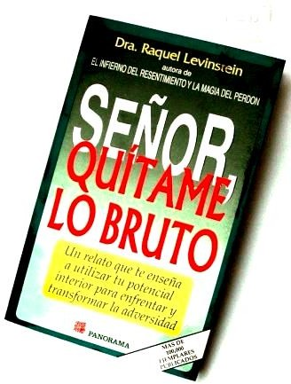
Letters 135
One Brother, who has known me for many years, had
the kindness of giving me this booklet as a souvenir of the magnificent Sat Arhat Day on September 22nd at the World Inner Ashram of the RedGFU, in Coatepec, Vera Cruz, Mexico.

I started reading it with good humor, then I became serious ly interested and ended up putting it aside with some fear,
because I thought: What if the Lord listens to me? What will I have left?

Then I started to read the e-mails I receive on the Internet and I felt even more afraid, not only for my- self, but also for many people I love. Anyway, I remain as I am.

Well, well, it is undeniable that we continue to advance, slowly. It seems that we already feel the need to get out a little bit of our "esoteric redoma," as one Lady qualifies our GFU, to do some work for the Human Re-education and pay the price of our primary education in Real Initiation. - By the way, we begin to see the influence of the Ladies in the Real Initiatory Tradition and that is the best symptom of our advancement, to slow down a little, at least, the fights for Power - among those who cannot - and also, to balance our masculine cravings for freedom with a little more love. Very soon we will have Real Initiation Ladies Gurus of the New Age. - No offense, please, to those of you who already are, I have not had the good fortune to look you in the eye.

The Real Initiation is for men, not for women - I was clarified. Do you believe that the Demiurge, the Maker, is male or female? It is clear that he is a man, not Demiurga.
How about seeing it as the One Source of the Feminine and the Masculine? Then it would be Gay
That is a problem of Reality, not of the Truth He represents. Slow down, please
The Truth or Cause of all Causes is Pure Potential, without limits. That Potential beats from within outward and from without inward, generating what our human consciousness qualifies as life and death, as day and night, as masculine and feminine.

Who told you?
Nobody told me, because I have always known that. What happens is that I did not remember it and now that I remember it, it turns out that the great sages from the most remote antiquity have plagiarized it.
Are you feeling all right? You don't have a headache or anything like that? I feel better than ever because I don't feel alone
Do spirits haunt you? Are you fond of Sacred Herbs?
I am fond of herbs because I am a vegetarian and all herbs are sacred: lettuces, quelites, papalo; including their richer relatives, corn, wheat, fruits and others, because they all have Life and Life feeds on Life because it always comes from the same source...
Well, well, tell me about it later. Do you want me to send you to one of the GFU Psychotherapists? No, please!

It is natural that modern minds, scientific and technical, are confused about these matters of Real Initiation, which has as many reasons for yes as for no, and even more so when the minds are of the religious type and see Moors with tranchets, infidels, schismatics and straddlers everywhere. The advantage is that communications are advancing at a rapid pace and we already have Yahoo Groups with very sincere and intelligent people, and also, with spies, catechists, Knights of St. John and moderators worthy of the greatest respect for their incredible feats of keeping their balance on a tightrope strung on all sides. But there we go, with some deeds well done and some consciences well done.

How do you consider yourself?
As a Human Being, aware of Being in the sacred and of being in the present, changing and mortal of my human nature
Does that make you think like a religious person, a scientist, or both at the same time? Makes me think as an Initiate
How do you define the Initiate?
As someone who knows it is not finished and never will be. In spite of death?
Not regretting death, but accepting the action of death in its relation to life. Do you consider Initiation to be a death cult?
Not only a cult of death, but also of life, of day and night, of good and evil, within the dynamic reality that allows Truth to know itself, by contrast and comparison, in the reality of the forms and existences of Space and Time.
Is that a new theory or an old doctrine?
Neither one nor the other, it is the truth of the Self that is reflected in the reality of the human. Which is a paradox
- The Human Being is also a paradox twice over, as Man and Woman, the same as the Universe, which is unity and diversity. Words belong to Reality and lack the capacity to express Truth. To be one and to be diverse at the same time. To be a Genome where billions of living beings, cellular, work for the existence of an individual. To be in BEING without beginning and without end and to be here and now, living and dying, is also a paradox. However, the experience that accumulates between the Being and the Human and forms the Soul, gives us distinctive characteristics and makes each head a world, but it is what gives us consciousness and allows us the margin of action that can produce causes to collect them as effects and influence the future with consciousness and adjusts us to the cosmic plan that we are producing among all. (*)

___
_ _ _ _ _ _ _ _ _ _ _ _ _

_ _ _ _ _

_ __

_ _ _ _ _ _ _ _ _ _ _ _ _ _ _

_ _ _ _ _

(*) This time I am plagiarizing myself, since the final part of this letter was published as an interview in a
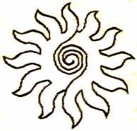
newspaper of San Salvador, El Salvador, several years ago, in its cultural section.)

Sat Arhat José Marcelli
September 29, 2007
www.redgfu.net/jmn

Original text in Spanish:
www.josemarcellinoli.com/2007/pdf/2007_cartas_135.pdf
Translation by: Marcos Paulo González Otero
email: gmarcosp@gmail.com
www.otero.pw
WhatsApp/Telegram: +52 686 119 4097
Version: 11092022-01
Please feel free to forward opinions and corrections.

