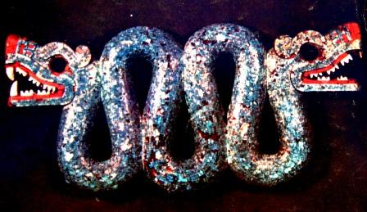

Letters 150

A phrase from my Notes 991-1000 stuck in my mind: This beautiful adventure of Consciousness that we are living. Which one? The era of Knowledge, not of erudition, but of Wisdom And what is that? Faith and Consciousness united. Faith in the essential unity of Life and Consciousness, realizing the enormous possibilities of the moment we are living. To be universal, to trust in the essential unity of the ALL in everything and to respect the diversity of the set of sets that is the Universe, in which we are a set of sets with its own particular consciousness.
So? To apply Wisdom by sharing our particular consciousness with other particular consciousnesses, with respect and gratitude. To offer what we have freely, without forcing anyone to take it, and to receive from others what we lack; that we lack a lot to be total, for the time being in this dimension where we are and in this life we are living. The possibilities are countless within our own project when we understand that it is not the only one or the best, but that it can always be better without losing its identity, its center, its essential unity of Being within the diversity of Living Beings that work for it, inside and outside of what we call "I".
Sometimes I make jokes saying that everything I say was plagiarized from thousands of years ago before it occurred to me to think about it, yes, but I also say that what I see every day and what I discover in the light of the same sun that illuminated them is different from what they saw and understood. History repeats itself, everything is already lived in the past and everything that the present gives us is new, without anything being disconnected from anything or anyone, because everything is one and diverse.
Each one has to live his own life and enrich his own with what the others live, in exchange for collaborating so that the others continue to grow. With the set of combined efforts that we have all made, we are beginning to overcome Space and Time that limit us and make us feel alone. With Wisdom we are overcoming the enormous distance that separates us from the Maker because we are discovering that we are also makers, since as Above is Below. Holy! Above Holy! In the middle Holy! Below, All is Holy, Sacred, Secret, Sacred, Sacred, Being.
We need to speak a universal language, not only mystical, for the chosen ones, Qabbalah? Pocho for the undocumented? No, universal How? Learning to see What? What the Light of the Sun says and all that the Light of the Sun does, what does it do? Let's see. It does everything here and now, including the water, air, earth and fire that create and recreate us in every instant of Time to maintain and enhance our form in Space, according to the new needs we acquire as we grow and those we discard as we move toward the unity of our present dimension. And the same with everything else we hear, smell, palpate, or taste, in order to have at each moment a better capacity to appreciate and value what we are living and discovering, until we understand the language of the seas, the rivers and the clouds; the language of the fire that is born in the Sun; of the wind that travels all over the world telling us sometimes with sweetness and sometimes with rage what is happening everywhere; the song of Mother Earth that lulls us from inside her body and sometimes corrects us to teach us to live with dignity.
Everything always has two heads, like the Omecoatls (Cuates) of the Toltec Ancestors, and everything has the purpose of becoming more and more conscious of Being what It Is: Unity in diversity, Universal.
The Universal Fraternity is Humanity, with its commercial brand tribes, its wandering walkers and its sects and sub sects....
The fact is that we are in the Age of Air and the Wisdom of the Air that travels to all the ends of the Earth and is capable of defeating Space and Time through the Internet to give us the opportunity to share or to exhibit our insecurity looking for culprits.
Sat Arhat José Marcelli
February 26, 2008
www.redgfu.net/jmn

Original text in Spanish:
www.josemarcellinoli.com/2008/pdf/2008_cartas_150.pdf
Translation by: Marcos Paulo González Otero
email: gmarcosp@gmail.com
www.otero.pw
WhatsApp/Telegram: +52 686 119 4097
Version: 07072022-01
Please feel free to forward opinions and corrections.

