◉
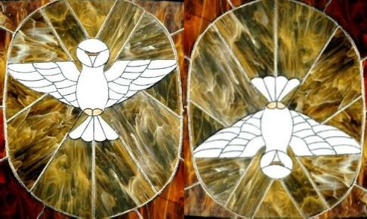
The Circulation of Light
Letters 152
Nothing is Created, everything is in a process of Initiation and Reinitiation, structured in Higher and Lower Octaves, of higher and lower consciousness. The Universes that form the Universe are eternal in their essence and diverse and changing in their presence. Unity is and is everywhere. Unity is Being, diversity is Nature and people. Each person and each thing is made within the scheme of the Universe, which is a set of sets of particles - atomic, molecular, cellular and organic - united around a Center of Gravitation that has a particular consciousness that is the sum of the consciousness of the particles of its body, the same in the very small as in the very large. This particular consciousness is the individual Soul and the ensemble of ensembles of individual souls is the Universal Soul.

The Soul serves as a means of communication between the Potential of Being and the form that reflects it in Space and Time in direct relation to its Soul. The Potential of Being is considered by modern scientists as Quantum Void. In spiritual language it is called OM-presence or simply OM. The Soul manifests the individual and the universal and adopts expressions more akin to Art than to science or religion, according to cultures, geographies, temperaments, ages and epochs. That is why it is said that human language has Soul and that its translations are only equivalences in other languages.

This must be taken into account when one seeks to attain the experience of Self, that is, the experience of the Sacred within the changing process of human life. In the Tradition of the Royal Initiates this experience of unity within diversity is symbolized as the Circulation of Light, of the Potential of the Self flowing into the Human as life and of the reaction of the human into the Self as consciousness (The Dove descending and the Dove ascending, from and to, a point in the center of a circle representing the Sun as the Source of Life and as the meeting point with the next dimension). The outline of this process is found on the Altar where the Cosmic Ceremony is officiated, with three elements on a horizontal plane,

- Matter, Energy and Mind, the human; - There is a symbol of the meeting of the Human with its Self on the spiritual plane, indicated by a lighted light inside a glass of red color. Above these four levels are three lights placed in triangular form symbolizing the Sacred, the Cosmic and the Absolute. In total there are seven planes of the Being and the Human within the Octave of the Universe where we are. (The denomination of Octave is due to the fact that the septenary of planes of a dimension, when it is totally reached by the Consciousness, is synthesized and becomes the First plane of the following dimension).

He who feels the need to know himself totally, beyond the norms established by conventional culture and morality, has to channel all the possibilities of his human nature through his Soul towards the initial experience of his essential nature of Being, without detaching himself from his human condition in order to initiate himself into the experience of the Sacred, of that which has no limits of form or existence, and lacks in itself any beginning or end.

For the common Human Being, this language is meaningless because it exceeds the scope of words that are limited to Reality; however, it has a subliminal effect when it is staged in Ceremonial and gradually becomes the Language of Silence, the language of the Sacred, of the Self in its communication with the human. The danger is that when someone believes he has understood something, he clings to what he believes and converts it into dogma and attributes it to some Master or to the Supreme Being. That is why the Schools of Initiation are necessary at various levels that find their culmination in the Secret Chambers, even though there are many individual reasons against secrecy.

What is important in the whole matter of the Sacred Initiatic Tradition can be appreciated in the security that each individual acquires about himself and in the confidence that he has in other individuals, without falling into naivety. It is not a question of adorations, edifying attitudes, oratorical or literary skills, but simply of security in the eternity of one's own Being within the limitations of the human person who lives it. The Degrees of Real Initiation, with robes, titles and reverent treatments, are only new conventionalisms that serve to stage in the great theater of real life the Wisdom of the Supreme Being, of the Being of all Beings, and to stimulate the efforts that are made to overcome human ignorance. Within this work of consciousness with universality, there is room for all concepts and tendencies that seek the dignity of Life and of all Beings of Nature, and all ideas, habits or doctrines that can degrade life are excluded by natural selection, without coercion.

It is necessary to reflect on this simple idea: Human Being - Universe. It is the key to be able to understand what the Sacred and Real Initiation is, here and now, in the present, without separating it from reality and without separating it from its Truth. Criticism is useless, with good or bad intention, we must experience here, in life, the Sacred. This is the Initiatic project.

Sat Arhat José Marcelli
March 5, 2008
www.redgfu.net/jmn

Original text in Spanish:
www.josemarcellinoli.com/2008/pdf/2008_cartas_152.pdf
Translation by: Marcos Paulo González Otero
email: gmarcosp@gmail.com
www.otero.pw
WhatsApp/Telegram: +52 686 119 4097
Version: 07072022-01
Please feel free to forward opinions and corrections.

