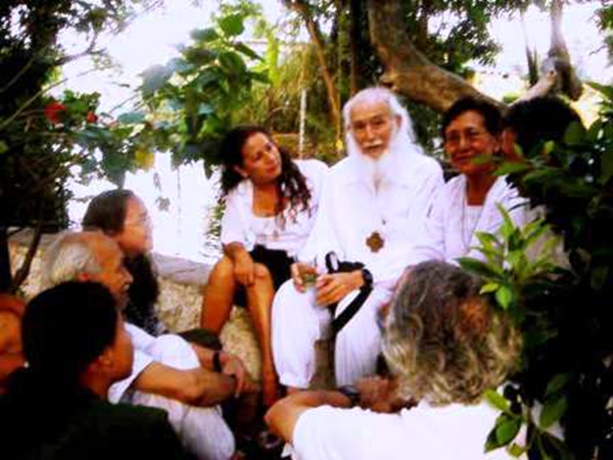
Letters 159
This morning at the RedGFU Ashram in Cuautla, State of Morelos, Mexico, there was good news and bad news. The bad news was that today, a few minutes into the day, the Very Reverend Gelong Don Antonio Iglesias ceased to exist in our Reality, to continue being in the eternal Being. A wave of kind, friendly and fraternal memories flooded the consciences of a couple of hundred Getuls gathered in the Multipurpose Room. Everyone knew him, everyone said good things about him, everyone blessed him.

Besides being a good man, which is the greatest quality of a Royal Initiate, Don Antonio was a Loyal Man, he remained faithful to his Master to the end, even though his family was divided and he had to face insistent pressures fomented from the South of America. He helped the Elder Brother to build the First Secret Chamber of the New Age in the middle of a salty wasteland in the dry bed of Lake Texcoco - which later became Colonia Campestre Aragon, in the eastern outskirts of Mexico City - in the company of the Great Disciples, now disappeared, Don Vicente Licona. He was also one of the eight builders of the "Second" First Secret Chamber of the New Era - when the first one was destroyed without the least respect - this time in the middle of a farming community north of Cuautla City, which today is the smallest and most significant RedGFU Ashram in the Aquarian world.

Don Antonio, who was known to his close friends as "Tigre Toño," would pick up his friends every weekend and take them from Mexico City to Cuautla in his Volkswagen van to work on the construction of the Ashram and to fulfill the Chamber. Among them he would take Rosita, Tania and Xochitl, our granddaughters, while I traveled the Americas to fulfill my Guru test....
Well, the good news for everyone - and for Don Antonio - is that yesterday afternoon the purchase of a new house to be annexed to the Cuautla Ashram was finalized, after several months of negotiations and work by the Getuls to raise about one million pesos, which were necessary for the purchase.

PAX... Very Reverend Don Antonio, we continue your work encouraged by your example.

Sat Arhat José Marcelli
May 18, 2008
www.redgfu.net/jmn

Original text in Spanish:
www.josemarcellinoli.com/2008/pdf/2008_cartas_159.pdf
Translation by: Marcos Paulo González Otero
email: gmarcosp@gmail.com
www.otero.pw
WhatsApp/Telegram: +52 686 119 4097
Version: 30062022-01
Please feel free to forward opinions and corrections.

