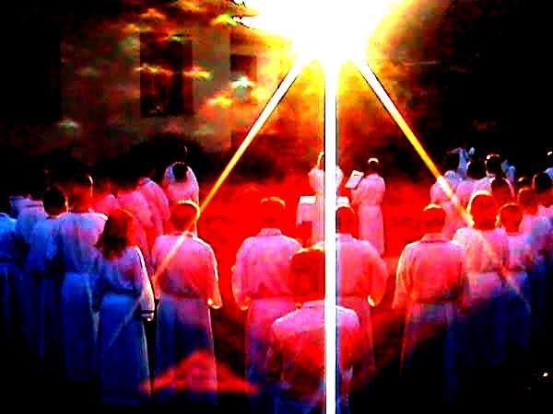

Letters 162

How are we doing at RedGFU?
Photo: Gl. Carlos Garcia

It is evident that this year our Solar Reaffirmation, popularly known as New Fire or Mooring of the Sun, improved a lot. It was performed in all the Ashrams of the RedGFU considered as Sacroteluric Centers, that is, places where the telluric Force is greater and, in addition, a work of High Initiation Chamber is done.
Can we consider that this Ceremonial is the most important thing that RedGFU does? Certainly not. It is just an act of attunement with the Cosmic Plan that moves Human Life, known since the most remote antiquity.
What, then, is the most important thing for the RedGFU?
The work in favor of Health and Consciousness, in all aspects of Universal Life, mineral, vegetable, animal, human and... Etc.
Does this mean that the RedGFU is an ecological institution as they are now called?
In our case, the ecological balance is a consequence, not a special work. If Health and Consciousness are achieved, the ecological balance is maintained in good shape. This is because Life is interdependent in all its forms of manifestation, nothing is detached from nothing and everything affects or favors us all, but the Human Being has the mission to increase his Universal Consciousness and apply it as an Impersonal Service, as indicated by the MSMA, Doctor Serge Raynaud de la Ferriere for our times.
Are you referring to the resounding New Age issue?
Not especially, for we have always been in the New Age, because we have always existed as Humanity in the Present and never in the Past or in the Future, which are only reference points that indicate to our consciousness whether we are advancing or stagnating and whether we are corrupting or degrading. I am referring to the circumstances of the present moment that now allow us to act with more amplitude, for better or for worse, due to the development of Science and Technology.
And how do you see it, are we doing well or are we doing badly?

I think we are simply confused, as the changes are happening very fast. My father, for example, lived in the days of the mule-drawn streetcars and saw the first passenger jets that operated in Mexico. I have traveled without much surprise in the great Jets that cross the Ocean in a few hours, with all the comforts for travelers, but I continue to be amazed with the virtual meetings that children do now through the Internet, handling with naturalness what for my childhood were miracles of Clairvoyance, Clairaudience and Gift of Ubiquity. We are still so misplaced that we are abusing the natural resources of our body and our Earth, and sometimes we even want to evade the wonderful moment we are living with the abuse of old and new drugs such as consumerism and yoga... Do you consider yoga as a drug?
Yes, when it is used to evade reality with psychic trances, induced by means of morbid quietism, to say something, like the yogi in a recent movie who spends three years, three months and three days meditating in a cave and when he returns to reality, he goes back to his old ways without having advanced anything.
Do you have the solution?
I am trying to find a solution for myself and I come across the issue of the Universe, in which I am totally involved.
Why do you feel involved? Are you a member of a Redemptorist sect?
Worse than that. I am an individual with a particular, individual consciousness, and I find that my consciousness does not coincide exactly with that of other individuals, because we do not have the same quantity or quality of particles in our particular consciousnesses. In other words, each head is a world and all worlds are particles of the universal consciousness. Then, I have no choice but to observe the course that the universal consciousness takes and collaborate with it to generate causes that follow a curved trajectory in Space and Time and return to me as luck, as destiny, good or bad, according to the causes that I promote. In synthesis: I have no one to blame for my destiny but my- self.
And what does Solar Reaffirmation, as you call it, have to do with your destiny?
Well, here I have to tell you something they taught me in elementary school: Everything in the Universe revolves around a center. The center of our Solar System is, precisely, the Sun. We, Human Beings, revolve around the axis of the Earth, which revolves around the Sun, therefore, the Sun has a force equivalent to that of all the planets that revolve around it, with a complementary charge to it. This maintains its equity, its equilibrium. Both forces share their potential. The Sun gives us energy to recreate and energize our Life process and we give it awareness of its Potential of Being. The same happens with us, Human Beings. Our Being is Pure Potential and we, as people, give it consciousness of Being. From this, it turns out that each of our particles and sets of particles have a center which, when associated with the centers of other particles, form more and more powerful centers until we reach the total individual who is the sum of the consciousness of all his particles and therefore has a particular consciousness of BEING in all his parti- cles and of keeping them revolving around his Being. What we did at the Summer Sols- tice was to reaffirm this unity of diversity in the Ritual of Solar Reaffirmation.
In all of this, where is God?
In heaven, on earth and everywhere, as Miss Josephine, our catechist, taught me when I was four years old.

Sat Arhat José Marcelli
July 9, 2008
www.redgfu.net/jmn

Original text in Spanish:
www.josemarcellinoli.com/2008/pdf/2008_cartas_162.pdf
Translation by: Marcos Paulo González Otero
email: gmarcosp@gmail.com
www.otero.pw
WhatsApp/Telegram: +52 686 119 4097
Version: 30062022-01
Please feel free to forward opinions and corrections.

