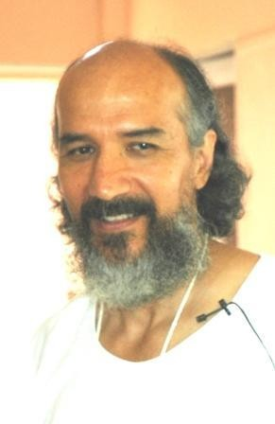
Letters 173

I continue to comment on the concerns of the Honorable Guru Gerardo Motoa:
Where are we going with our Great Universal Fraternity and its Degrees of Consciousness?

We are going towards the Great Universal Fraternity, to the Unity with Diversity, to the Universe, where we are already and we only need to recognize all of us in one, and each one in all.

Is not what we call Pure Unity an Absolute Entity that we call God?

And don't we call it God because it includes everything, including all of us, as individuals, of various colors, races, beliefs, consciences and so on?

If God lacks something, that something is us. But he lacks nothing, no matter how much we are accused of being racists. What happens is that we are amazed by the phenomenon of God, and we grab what we can. If something gave us results, which we consider positive, even if others consider them negative; if something served to make us realize and be able to manifest it united for a certain time, we think that it will keep us eternally united, to give us the power of strength, without thinking that God is constant change, where all his possibilities confront each other until we discover that they are of the same essence, and we repeat the same story.

The same thing happens to all of us, in one way or another. Then Science comes along and tells us that what once happens, always happens, and so on, the nail is well and truly hammered in, without thinking that when Science says it, it says it because that is as far as our Con-Science goes and we can prove it. Then science itself tells us that, in the end, they are all possibilities. On the one hand our beliefs tell us that everything is summed up in the AUM, and on the other hand Science and Con-Science tell us that they are only possibilities.

The first thing that comes to mind is duality, the Self and the Human. The positive part and the negative counterpart, the two halves of knowledge, which propel us upward, to give us more opportunity to know ourselves, always upward and forward, in periods that can be measured in cycles and that we call them Degrees of Consciousness, about which we talk a lot and discuss vainly, and anyway, we measure with our Consciousness that gives us the power to say yes, up to here, and there is still much to go, not by reason of those who measure the consciousness, but by reason of those who were already measured in previous cycles. Very well, since this is what I have just read in the concern of the Honorable Guru, in his new question, implicit in his writing: "In case anyone is interested..."

Sat Arhat José Marcelli
October 13, 2008
www.redgfu.net/jmn

Original text in Spanish:
www.josemarcellinoli.com/2008/pdf/2008_cartas_173.pdf
Translation by: Marcos Paulo González Otero
email: gmarcosp@gmail.com
www.otero.pw
WhatsApp/Telegram: +52 686 119 4097
Version: 14062022-01
Please feel free to forward opinions and corrections.

