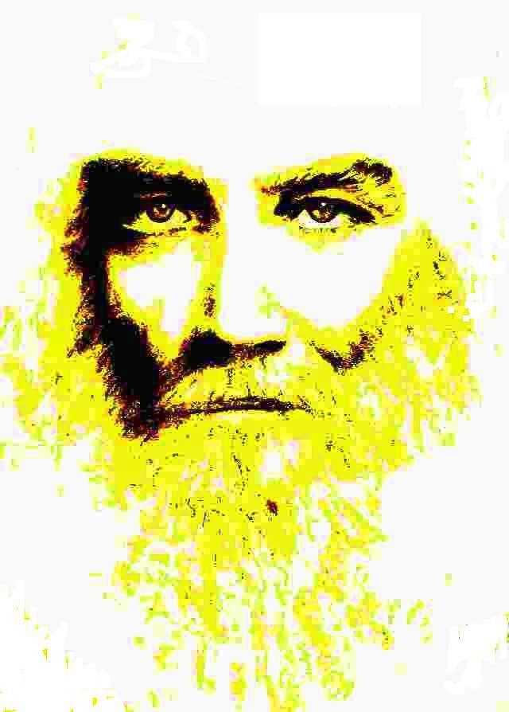

IV - THE SEVEN SEALS OF THE LION OF THE TRIBE OF JUDA

FOURTH SEAL:

GOD

THROUGH THE HUMAN FORM BEGINS TO KNOW HIMSELF

MVHM
All of us, by nature, by race, by heredi ty, or by education, have spiritual, mystical or religious characteristics, at least slightly different, no matter how much religious doctrines pretend to establish some absolute belief directly inspired by God or by one of His Envoys. Therefore, from the religious point of view it is almost scandalous that God uses the human form to know Himself. There is nothing to discuss about that. Either one believes or one

does not believe. If one believes, without reservation, Faith solves everything - it is not irony - because Faith concentrates all its strength in a Unique Being, that is, in the Supreme Being who is the Source and Goal of all Beings, and therefore has access to the Truth unconsciously and can occasionally act innocently, regardless of the consequences of its actions being reversed against itself as bad effects, since a perfect justice governs the world and, as it is popularly said, he who innocently sins, innocently condemns himself.

In the Tradition of the Royal Initiates, Faith is respected. It is considered as the highest stage of human experience, especially when it manifests as Love. However, respect for the Freedom of the Beings it loves is demanded so that it does not stagnate in the fanaticism that leads to hatred, holy war and self- destruction. This is so because Faith is spiritual and the spiritual is at the summit of the human process and at the base of what is still secret, sacred or Sacred, therefore it is subject to the duality of the human as Love and Freedom; to the rhythm, to the ritual, of expansion and contraction, of Space and Time that characterize Human Nature which, by necessity, in feminine and masculine is subject to life as expansion and growth and to death as contraction and synthesis, within a spiritual process, characterized by the systole and diastole of the heart, the Fourth Chakra, according to the Yogis, which is the intermediate level of seven, the seven levels of our present human dimension.

Why does He begin to know Himself, does He not know everything, does He not originate and culminate everything in Himself?
When one has true faith, these kinds of questions are unnecessary. When there are any reservations one must turn to Consciousness for explanations, even if these have to be relative, that is, in the meantime no better answers are found, for we have already said that Consciousness is never finished, but that when it is united with Faith it becomes Wisdom, in the Tradition of the Real Initiates, and for that very reason, any Real Initiate is on the margin of worship, although he always remains within the reaches of admiration and serves as a living and inspiring point of reference. The MSMA said: Do not look at me or see my finger, see what I am pointing to... Is it clear? To a greater abundance, the MVHM repeated to us several times: One matter is Jose Manuel Estrada as a Human Being and another matter is the ELDER BROTHER...

When the Light crystallizes The Warrior of Light is born

God, it is clear, is in the particles of crystallized light in solid and liquid form (The Solve Coagula of the Alchemists) and in the photons of light that activate the crystallized light and make it enter the pro- cess of Photosynthesis which is the beginning of the return to its Source as Organic Life, that is to say, that the SAT, the Light, does not remain eternally in the AN, but evolves, in a curved and continuous, spiral form, to return to the SAT (SAT - AN - SAT, speaking as an Initiate, not as a Theologian, said with all respect for a noble profession) Photosynthesis obeys laws (explained by the previous Seal) but does not work by conscience. This process of photosynthesis, in any case, is polarized and dynamic, but not self-conscious in vegetables; it becomes instinctive in animals; when it reaches the Human plane it becomes individualized and acquires a small margin of option to choose and assume the responsibility of its choices and gradually advances until it surpasses the human and begins to be conscious of the Total Cosmic Plan, which it serves unconditionally because it is its own plan. It is the case of the authentic Real Initiates....

Forge your weapons one by one And take the course of the earth Where all roads
They go everywhere

And they arrive at the same place

What comes out of Unity, returns to unity after a very long process, counted in human time, which is only a flicker of eternity. Countless days, nights; lives and deaths; systoles and diastole of the heart of the Cosmos, finally.

The door opens and the warrior walks through it And is transfigured in consciousness of the LIGHT

Sat Arhat José Marcelli
January 15, 2008
www.redgfu.net/jmn

(*) Bridges 68. The Warrior of Light. 7 / 14 / 2007

Original text in Spanish:
www.josemarcellinoli.com/2008/pdf/2008_los_siete_sellos_04.pdf
Translation by: Marcos Paulo González Otero
email: gmarcosp@gmail.com
www.otero.pw
WhatsApp/Telegram: +52 686 119 4097
Version: 08082022-01
Please feel free to forward opinions and corrections.

