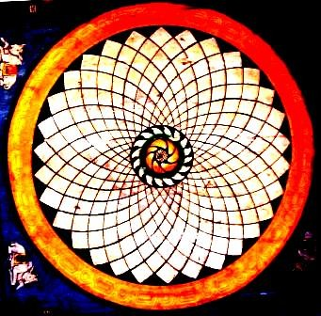

V - THE SEVEN SEALS OF THE LION OF THE TRIBE OF JUDA

FIFTH SEAL:
S I L E N C E
Silence
At the heart of the words There is silence
And further inside In the heart of silence
The song of life is heard In silence

Sat Arhat José Marcelli
January 23, 2008
www.redgfu.net/jmn

Original text in Spanish:
www.josemarcellinoli.com/2008/pdf/2008_los_siete_sellos_05.pdf
Translation by: Marcos Paulo González Otero
email: gmarcosp@gmail.com
www.otero.pw
WhatsApp/Telegram: +52 686 119 4097
Version: 08082022-01
Please feel free to forward opinions and corrections.

