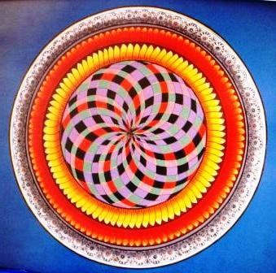

VI – THE SEVEN SEALS OF THE LION OF THE TRIBE OF JUDA
SIXTH SEAL:

BEING
To be is to be free
And to live in every instant
And to discover oneself in every image Of the countless faces
Of Life

Sat Arhat José Marcelli
January 24, 2008
www.redgfu.net/jmn

Original text in Spanish:
www.josemarcellinoli.com/2008/pdf/2008_los_siete_sellos_06.pdf
Translation by: Marcos Paulo González Otero
email: gmarcosp@gmail.com
www.otero.pw
WhatsApp/Telegram: +52 686 119 4097
Version: 08082022-01
Please feel free to forward opinions and corrections.

