Letters 186
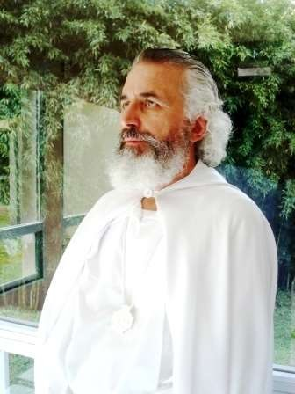
After a week of cloudy skies with Chipi - Chipi, a splendid day dawned on January eighteenth in Coatepec, Veracruz, Mexico. Despite the weather, the celebrations for the day, dedicated to the MSMA, began the day before, with mañanitas, an exhibition of paintings by Lila Marcelli and her stu- dents, and two concerts, one by Walter Carrillo - the hero of the Casa Sede in Toluca with his Betlemanía
- with violin and piano, and the other by Emanuel Vélez accompanied by three cellos that played at full length.

The following day, it was all hands-on deck with the graduation of three Gag Pas, Gloria Toxqui, Victor Cortes, and Juan Rangel, and three Gelongs, Marcelino Salazar, Miguel Angel Martinez Gamiño and Antonio Iborra, all of whom were tested with RedGFU and Order work.
Gurú Carlos Moisés García

Hugs, congratulations, souvenir photos, joy, above all joy, for having consecrated the three Gag Pas and three Gelongs ready to go around the world giving the example that humanity has its own dignity and that its salvation is won by sharing the good that we all have, without grudges and without sadness, ready to be Universal, to seek our Unity as humans to discover the one Being, which we all are.

Celebration of the joy of being alive and of discovering that we can share something to achieve a common goal under the guidance of the one who sets the example, the MSMA, with his attitude of following the path of Consciousness to build together the final goal of this Octave of Manifestation, which is to build a world where we all participate in the Unity that is common to us, the Universality - the LINE as we call it in the RedGFU and its Lineage - where we all participate in the same purpose according to the experiences that each one accumulates in his Consciousness.

There were different meetings to reach agreements. In all of them the need to follow the Line marked by our Masters and in particular the one shown by our Master, which is nothing more than the General Line as a conjunction of all the particular Lines, according to our individual experiences, was highlighted. It was a day of authentic celebration for all according to the capacity of each one.

Sat Arhat José Marcelli
January 20, 2009
www.redgfu.net/jmn

Original text in Spanish:
www.josemarcellinoli.com/2009/pdf/2009_cartas_186.pdf
Translation by: Marcos Paulo González Otero
email: gmarcosp@gmail.com
www.otero.pw
WhatsApp/Telegram: +52 686 119 4097
Version: 13052022-01
Please feel free to forward opinions and corrections.

