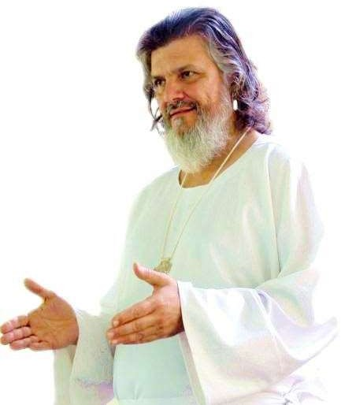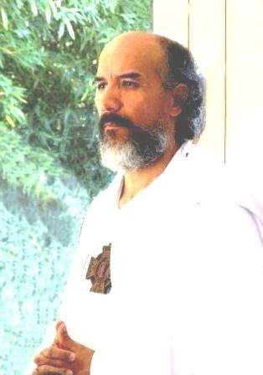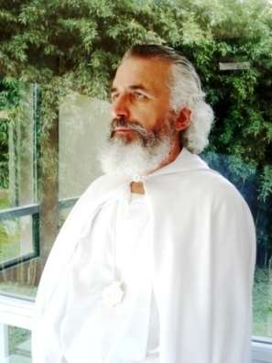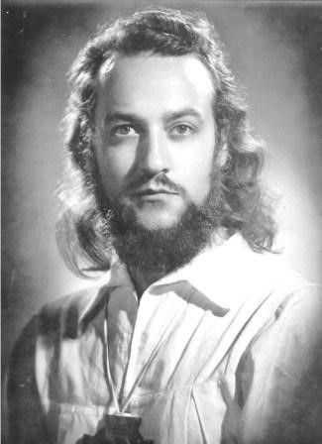

Letters 190
We are in the middle of a change of Initiation in Reality, no more and no less. We are initializing ourselves in Reality, we are step by step, understanding what we can include in Reality and what we have to exclude from it. We are rehearsing, according to our historical moment, what works for us and what does not fit yet at this moment. It is not a matter of getting ahead of ourselves, but of living what is right, provided that we keep in reserve what corresponds to a later time and also so as not to repeat what is already obsolete. We must be very awake and be sensitive to what we can live fully, provided that it is not the only thing. There is much more at every moment.

Naturally there are reservations to repeat what went well, in favor of this or that set of Human Beings and reservations also to go in haste with what we already know and can know better. This is included in daily life, in all areas, each one brings a particularly developed tendency and wants to impose it, either for good or for bad. It is not easy to have everyone in harmony. That is one of the important parts of the Initiation, to make everyone advance and to be convincing with the example we give to others. There are also those who contribute nothing and criticize everything that does not favor them.

Faced with this panorama, it is necessary to have a sense of the universal to embark on an enterprise such as ours, or to take advantage of what favors us, knowing that sooner or later Life will pass the bill to us, and we will have to start again with our interests loaded against us. That is to say, that somehow, we understand what is valid and what is not, independently that at the moment it favors us. This is not skin-deep mysticism, but in any case, it is mysticism deeply rooted in the conviction that we are all going towards an overcoming that transcends us and to which we have to attend sooner or later, for the simple reason that there is unity in diversity.

Historically it is understandable that we are not all the same and that each one of us fulfills a function, no matter how insignificant it may seem. The political, socialist, capitalist or absolutist systems, basically, are wrong and we are not beginning to live. We cannot take them as models in the Real Initiation, which by the way, has no political aspirations, but is inclined to Impersonal Service, which is considered as a symptom of political weakness at least or a crass impossibility by those who have a broader view, because everyone, Initiates or not, we all have a motive of interest, at least religious to help God.

However, it must be said that Real Initiates are not interested in profiting by making amends to God, or to anyone else, outside of what is common to all. To work for a living and make a living as far as is deemed proper with wife, children and natural obligations, and only after this is it considered lawful to undertake the quest for Initiation, to burden oneself with much more work, with no right to anything.

That is why it is not easy to find someone to represent you and guide you by example to know how and when to give to each one, at the right time, to become a living example, as a Master, and to indicate to the one who favors them with the disciplines and the necessary degrees to fulfill them impartially.

For an Initiate, Reality is the antechamber of the Sacred, and he cannot reach the Sacred if he does not pass through the Real, and the Real is what is lived, and when something is dis- covered that becomes part of Reality, it turns out that it ceases to be Sacred. The Sacred, therefore, is only the Sacred that is unknown, at least in this Octave of Manifestation, which is one of the seven into which we divide the Universe.

An Initiate, therefore, is never finished. However lofty he may seem to us, he is always lesser to those who advance before him, but his presence is inspiring, unless one has contrary intentions.

This gives rise to Lineages, to the appearance of Lines, according to the Master who inspires them. For example, above the Great Fraternity that comprises us all, there are several Line- ages in the Supreme Order of Aquarius, precisely the one in charge of inspiring the Universal Fraternity. It can be of a single Master, who due to his conceptual richness inspires different things to his Disciples and that each one of them explores some of his concepts and puts them into practice, forming his own Lineage. He may not understand the totality of the teaching of the Master, the Master of Masters, or he may give a different twist to his teaching, in any case he will form different lineages, which will finally add up his discoveries, once his mission is accomplished. This is the case of Doctor Serge Raynaud de la Ferriere whose disciples and the disciples of his disciples have fostered different currents that nevertheless retain some- thing of their original source.

The so-called Elder Brother, being his first Disciple, pretended to keep the original teachings and gave them to his disciples forming a Lineage. This gave rise to one of them giving them a very different value than all the others, claiming archaic shamanism, without renouncing to follow the Lineage of the Elder Brother.

The others followed as far as possible the teachings of the Elder Brother and those of his Master and are advancing towards a possible culmination in teachings that are derived from them. Finally it will be seen who adjusted to the true and it will be the historical perspective that will mark the possibilities of some and others. What can be seen from now on is that the thought of Master Serge Raynaud de la Ferriere gives for all.

Sat Arhat José Marcelli
February 8, 2009
www.redgfu.net/jmn

Original text in Spanish:
www.josemarcellinoli.com/2009/pdf/2009_cartas_190.pdf
Translation by: Marcos Paulo González Otero
email: gmarcosp@gmail.com
www.otero.pw
WhatsApp/Telegram: +52 686 119 4097
Version: 12052022-01
Please feel free to forward opinions and corrections.

